Before going into the application, you need to have an account to log into it. First step I need to create a database and a users table in database. This table will show all usernames and passwords created. Especially for each user password I use md5 password hashes, which mean anything the user set their password it will convert into a 32 digit in database table. By doing this way, user’s password get protected.

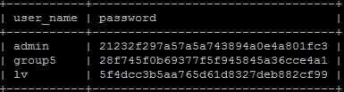

If you login as an admin, you will have the right to go the admin page and control other user. Other use won’t able to see the link for admin page.

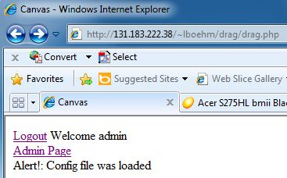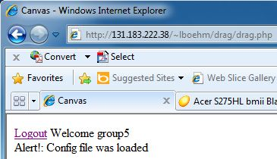

Also in admin page, you can create new users; remove any user and view all users have created. To adding new users, you need to enter your password 2 times with make sure they are matching. After you created an account, all the record will go to database as we showed above. To remove a user, you just need to enter username, immediately that username get remove off the database.

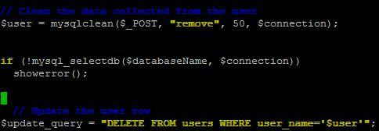   
 Instead of going to databases to check the entire user, we coded a command with just one click to help bring all the username and password show up on the browser.

